******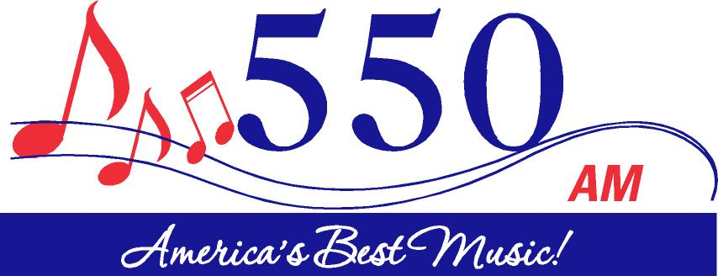

**EEO Public File Report**

**For**

**WIOZ-FM & WIOZ(AM)**

**Southern Pines, NC**

**This EEO Public File Report**

**Covers the One-Year Period Ending July 31,2024**

**200 Short Street**

**Southern Pines, NC 28387**

**EEO Public File Report**

This EEO Public File Report is filed in the online public inspection file of each of the stations in the Employment Unit, pursuant to Section 73.2080(c)(6) of the Federal Communication Commission’s (FCC) rules.

**WIOZ FM, WIOZ AM**

During the one-year period ending on July 31, 2024, the station filled the following full-time vacancies:

**No Vacancies/Hires During this one-year period.**

**ATTACHMENT B**

**MENU OPTION ACTIVITIES**

**MENU OPTION ACTIVITIES**

Stations WIOZ-FM and WIOZ(AM) have engaged in the following outreach activities during the year covered by this report:

|  |  |  |
| --- | --- | --- |
| **Activity Classification** | **Type of Activity** | **Brief Description** |
| 1 | Career Fair | *Moore County Schools Career Fair at The Fair Barn (February 16, 2024) – Personnel in attendance: Program Director, General Manager, Operations Manager, Production Director & Marketing Consultants. |
| 14 | Management Training | Muirfield Broadcasting currently sends our Office Manager to attend monthly meetings of the Human Resource Executive Association (HREA). This membership and our Office Manager’s attendance at the HREA’s monthly meetings allow Muirfield Broadcasting to adapt and evolve so that we can continue to provide equal employment opportunities and prevent discrimination.  Our HREA membership began in August 2019 and currently runs annually. |
| 8 | Training Program to Enable Station Personnel to Acquire Skills for Higher Level Positions | Monthly Sales Meetings/Trainings are held for sales account executives. During these meetings, among other things, account executives are provided training on how to better preform their job; the aim of the training is to equip the account executive with skills and strategies that would qualify them for promotions within the company. |
| 4, 14 | Participation in Community Events Relating to Broadcasting Employment Issues; Management Training | Training Session for Human Resource, Senior Level Leaders, and managers. During Talent Symposium on October 2023 featuring keynote speaker, Dr. Melissa Furman! This session hosted by Moore County Chamber of Commerce, Sandhills Community College and Moore County Economic Development. In this session training was centered around how to recruit and retain a Multigenerational Workplace. Personnel in attendance: General Manager, Marketing Consultants |